RSM INTERNATIONAL SCHOOL
CLASS 3
PT -1 SYLLABUS: 2022-23
English Grammar

Book: PC Wren’s
Ch:1 Sentences
Ch:2 Nouns
Ch:3 Nouns: Types
Ch:4 Nouns: Countable and Uncountable
Ch:5 Nouns: Singular and Plural
Ch:6 Gender
English literature
Ch:1 The golden touch
Ch:2 The Fortunate pedlar

Maths
Ch 1 Numbers and numeration
Ch 2 Addition

Social Studies
Book: Earth Alive (S.Chand)
Ch 1 The Earth: Where we live.
Ch 2 The Earth in space
Ch 3 How the Earth moves?
Science
Ch: 1 Eating habits of animals
Ch: 2 Keeping safe
Ch: 3 Housing and clothing

GK
Page nos: 1,2,3,4,9,10,11,12,13,16,17.
Computer

Ch 1 Introduction to computers
Ch 2 Learn to use MS Windows 10

Moral Science
Ch 1 and Ch 2
Hindi

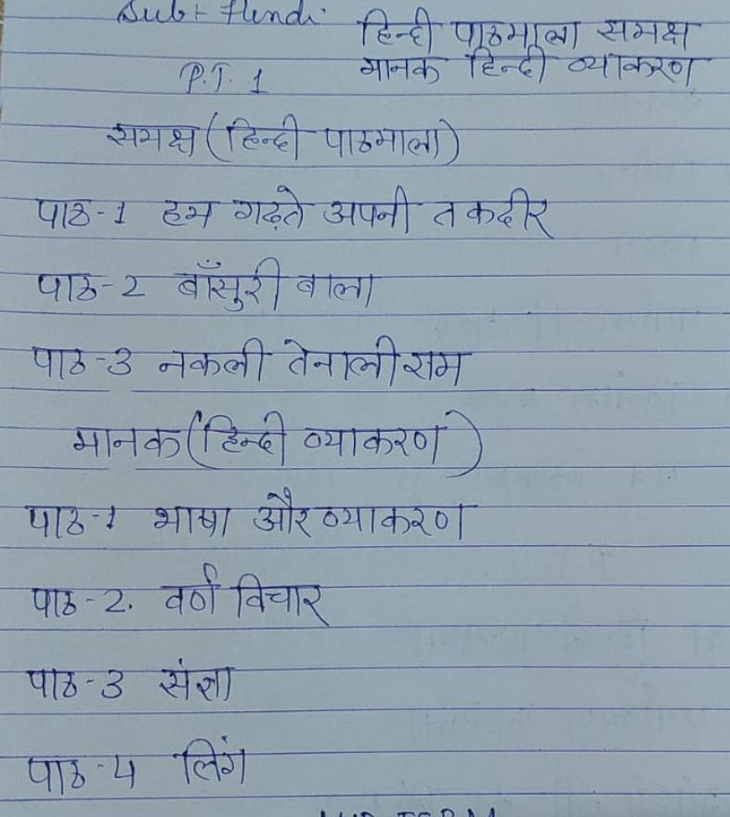
MID-TERM SYLLABUS: 2022-23

English Grammar
Ch 7 Possessive Noun’s
Ch 8 Adjectives
Ch 9 Degree of comparison
Ch 10 A, An, The
Ch 11 Pronouns
Ch 24 Words
Ch 25 Listen and speak
English Literature
Ch 3 How the Sun was rescued
Ch 4 Mowgli Joins the Wolf pack homes
Ch 5 Project Sunshine

Science
Ch 4 Soil
Ch 5 Solids, Liquids and gases
Ch 6 Living and non living
Ch 7 Parts of a plant

Social studies
Ch 4 Model of the Earth
Ch 5 Water and weather
Ch 6 Soil
Ch 7 Directions
Ch 8 India my country
Ch 9 I love India

Maths
Ch 3 Subtraction
Ch 4 Multiplication
Ch 5 Division
Ch 6 Geometry
GK
Page nos: 18,19,20,21,22,23,25,27,28,30,31,32,33,34,35,38,39,40,41,42

Computer
Ch 4 Introduction to MS Word 2005
Ch 5 Editing and formatting in MS Word 2010.
Moral Science
Ch 3,4,5

Hindi
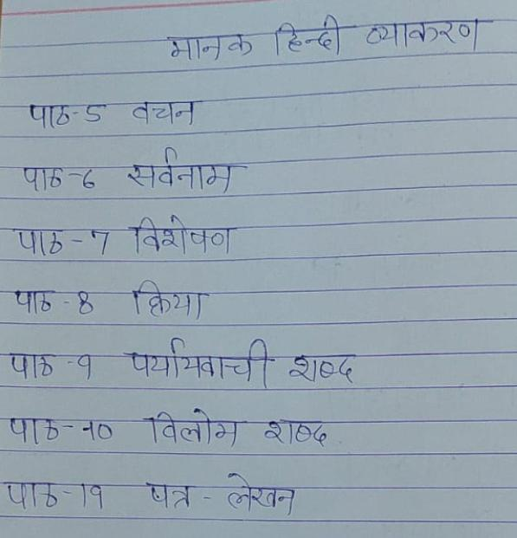
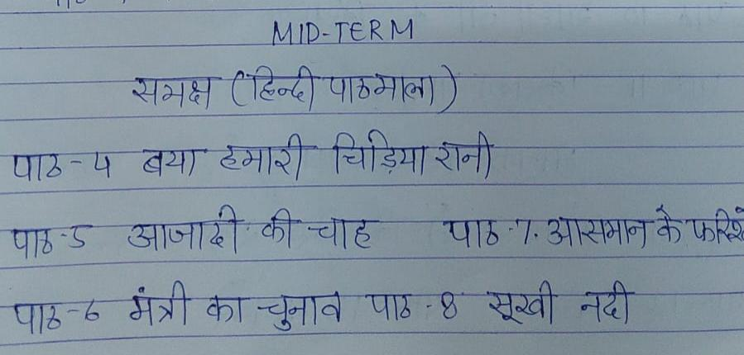
PT-2 syllabus 2022-23

English grammar
Ch 12 Verbs
Ch 13 Tenses
Ch 14 Simple past
Ch 15 Simple future
Ch 16 Can, Cannot, Should, Should not
Ch 17 Short forms
English literature
Ch 6 The girl who hated books
Ch 7 Exploring an underwater world

Maths
Ch 7 Fractions
Ch 8 Money

Science
Ch 8 Birds
Ch 9 Our body
Ch 10 Measurements

Social Studies
Ch 10 Delhi and Kolkata
Ch 11 Mumbai and Chennai
Ch 12 Other Indian cities –I,Ch 13 Other Indian cities -II
Computer
Ch 3 Paint 3D
Ch 8 Introduction to internet

GK
Page nos : 43,44,45,46,47,48,49,50,51,52,53,54.
Moral Science
Ch 6 and Ch 7
Hindi

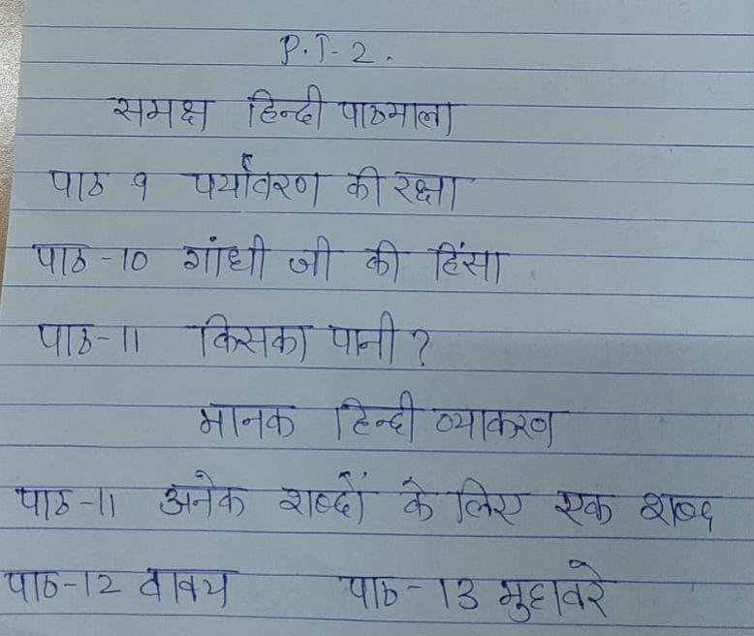

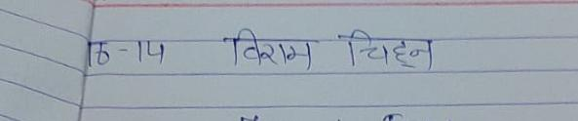

FINAL TERM SYLLABUS 2022-23

CLASS 3
ENGLISH GRAMMAR
CH 18 ADVERBS
CH 19 PREPOSITIONS
CH 20 CONJUNCTIONS
CH 21 INTERJECTIONS
CH 22 COMPREHENSION
CH 23 COMPOSITION
ENGLISH LITERATURE
CH 8 THE FARMER WHO BOUGHR A WELL
CH 9 THE BOY WHO BOUGHT A GRAIN
CH 10 RAJA’S USEFUL COLLECTION

MATHS
CH 9 MEASUREMENTS
CH 10 TIME
CH 11 SYMMETRY AND PATTERNS
CH 12 DATA HANDLING
CH 7 FRACTIONS
SCIENCE
CH 11 LIGHT, SOUND AND FORCE
CH 12 AIR, WATER AND WEATHER
CH 13 THE SUN, MOON AND STARS
CH 14 OUR EARTH

SOCIAL STUDIES
CH 14 Let us celebrate
CH 15 Symbols of national identity
CH 16 Let us travel
Ch 17 Let us communicate
Ch 18 Pollution
Ch 19 Story of Early man
G K
Page nos: 55,56,58,59,60,61,62,63,64,65,66,67,68,69,72,73.

COMPUTER
CH 6 What is coding
CH 7 introduction to scratch
MORAL SCIENCE
Ch 8,9,10

HINDI