R.S.M INTERNATIONAL SCHOOL
PREP Curriculum
1-QUATER SYLLABUS

We welcome our little ones at R.S.M INTERNATIONAL. We at RSM extend a warm &nurturing environment, which will help the child to develop physically, cognitively and more importantly, socially and emotionally. The child in RSM, experiences that he belongs to the School and the School belongs to him. To facilitate the child’s overall development, we have planned the following activities.

Morning exercises, National Anthem and Yoga activities to be done every day.
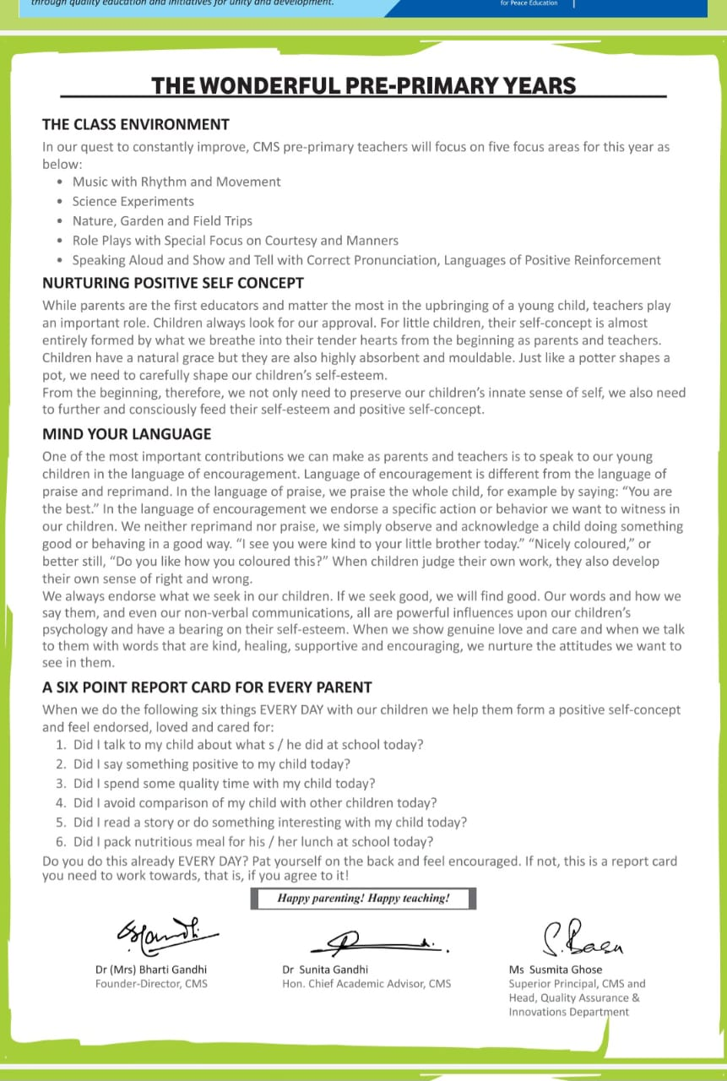

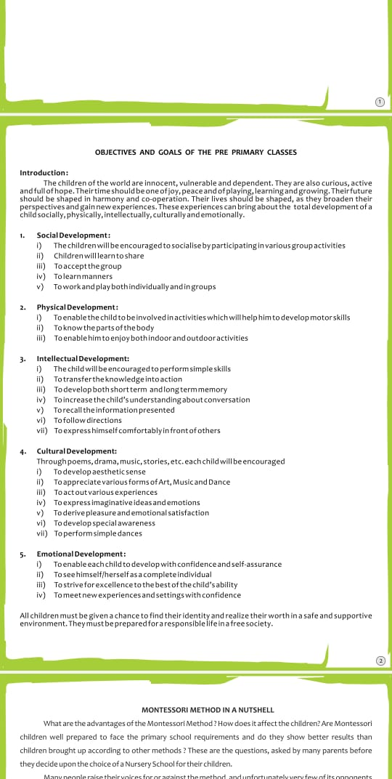

Theme of the Quarter: Summer
Montessori Activities

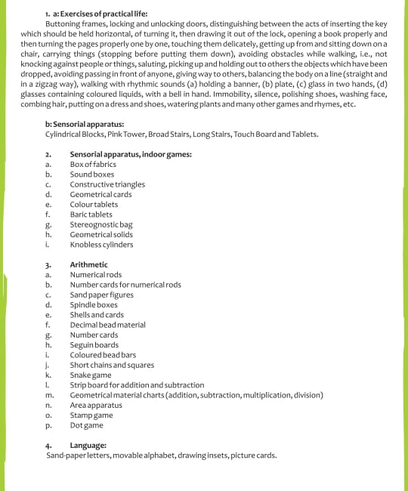

Montessori Activities
Practical Life Exercises:
- Walking on the line.
- Transferring water with the help of a sponge
- Transferring marbles with the help of tongs
- Transferring coloured balls with the help of a ladle
- Transferring of beans from bowl to another bowl with the help of spoon.

Sensorial:

- Introduction to different sizes through Pink tower and knobbed cylinder
- Introduction to colour –Red through Primary colored tablets.
Shapes and Solids:
- Introduction to shapes – ‘Triangle’ through puzzle
- Introduction to solids – ‘cone’ through geometric solids

Language:

- Introduction to Letter a through sandpaper letter and Phonics sound Ae.
- How to introduce yourself(Name,Age,Gender )
- Name of your favorite things(colour,Toy,Dreaa,Cartoon,Food,Fruit,vegetable,Animal)
- Rhymes related to themes and topics(My Red ballon,Brush your teeth)

- Story telling: The capseller and the Monkeys, Goldolocks and the three Bears.

Mathematics:

- Reinforcement of Seeping line, Slanting lines, Curved lines.
- Introduction to Numbers 1 to 5 through sandpaper numbers.
- Number Rods 1-5: associating with number cards
- Spindle box

Culture:
- Learning about community helpers – “sailor” and “Electrician”
- Wonders of the world – The great wall of china
- Summer clothes – T-shirts,skirts,shorts,caps,sunglasses
- Summer fruit-Orange, watermelon,Apple,Mango,Grapes,Muskmelon
- Summer vegetables- Tomato, Cucumber ,ladyfinger,Bottleground etc

Morning Prayers – Assembly Time

- God’s Love, We shall overcome, “Itni Shakti humein do na data”,Jan gana mana,Gayatri mantra

Academic Curriculum

English
1)Alphabets capital letters A to Z.
2) Small letters a to z.
3)Vowels ‘a’ and ‘e’ sound words.
Rhymes-1)God bless
2)Johnyjohny yes papa
3)Aeroplane
4)Phonics
HINDI
1)स्वर
2)व्यंजन
3)बिनामात्रावालेशब्ददो,तीनचारअक्षरवालेशब्द!
कविताएँ- 1)गिनती
2)सवेरा
Maths-

1)Counting from 1 to 50
2)Number names from 1 to 20
3)Table –“0 &1”

EVS-
Coloursname,Bodyparts,Daysname,
Fruits name
& Vegetable names.

Highlights of the Quarter

ORIENTATION DAY:- 10-4-2023
RED COLOUR DAY:- 13-4-2023
VISIT TO UMED PALACE:- 26-4-2023
RAIN DANCE:-4-5-2023
STORY TELLING:-12-5-2023

Your child is special. His/her potentials are special. Do not compare him/her with other children. Each child has a different pace for acquiring different skills. Be patient and have faith in your child.

